OFFICIAL COORDINATION REQUEST FOR
NON-ROUTINE OPERATIONS AND MAINTENANCE

COORDINATION TITLE- 23BON024 MOC Old Navlock dredge placement
COORDINATION DATE- 31 May 2023
PROJECT- Bonneville Lock and Dam
RESPONSE DATE- 9 November 2023

Description of the problem - The Corps is proposing to install new concrete stoplogs across the upstream entrance of Bonneville Dam NavLock 1 (NL1), and into the existing stoplog slots. NL1 has been inactive since the 1990s,and the stoplogs will be used to dewater NL1 so inspections / maintenance can occur. The new stoplogs will be installed via barge and no mods to existing staging areas or access routes will be needed. Prior to installation, dredging is required of approximately 2500 CYs of accumulated sediment at the NL1 upstream sill to allow for watertight placement of the new stoplogs. The dredged material is proposed for in water placement downstream of the dam via barge in the active flow areas at Columbia River flow lane RM 141 (note: placement site revised at recommendation of fish biologists due to determination that previous proposed location is active spawning grounds for chum salmon). Comprehensive sediment testing has been accomplished and material has been approved as suitable for in water disposal by ODEQ and USEPA reps via the Portland Sediment Evaluation Team (PSET) process on 22 Feb 2023.
Update Fall 2023: while not mandated, USACE is currently preparing follow on testing (Fall 2023) of the NL1 sediment via core sampling to definitively characterize the dredge prism and further ensure suitability for in water placement. The Fall 2023 Sampling Analysis Plan (SAP) for the Bon NL1 sediments (Full Prism Analysis) was recently approved by the full PSET on 19 Sep 2023. (Reviewing PSET Agencies: U.S. Army Corps of Engineers, U.S. Environmental Protection Agency, Oregon Department of Environmental Quality, Washington Department of Ecology, U.S. Fish and Wildlife Service, National Marine Fisheries Service). If the sediments are subsequently found not suitable for in water placement, an appropriate upland disposal site will be utilized. Proponent requests dredging and in water deposition of ~2500 CYs (PSET tested suitable for in water placement) sediment for Bon Navigation Lock 1 inspections and maintenance.
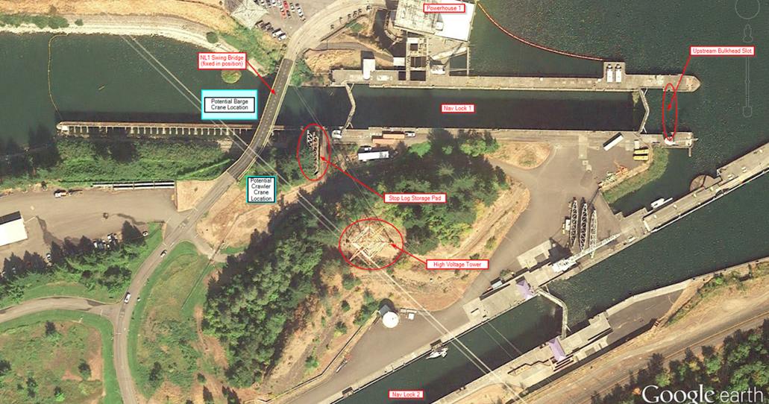
Figure 1-1 Bon Dam Project area with NL1 Upstream Bulkhead slot (site of dredge action) at far right

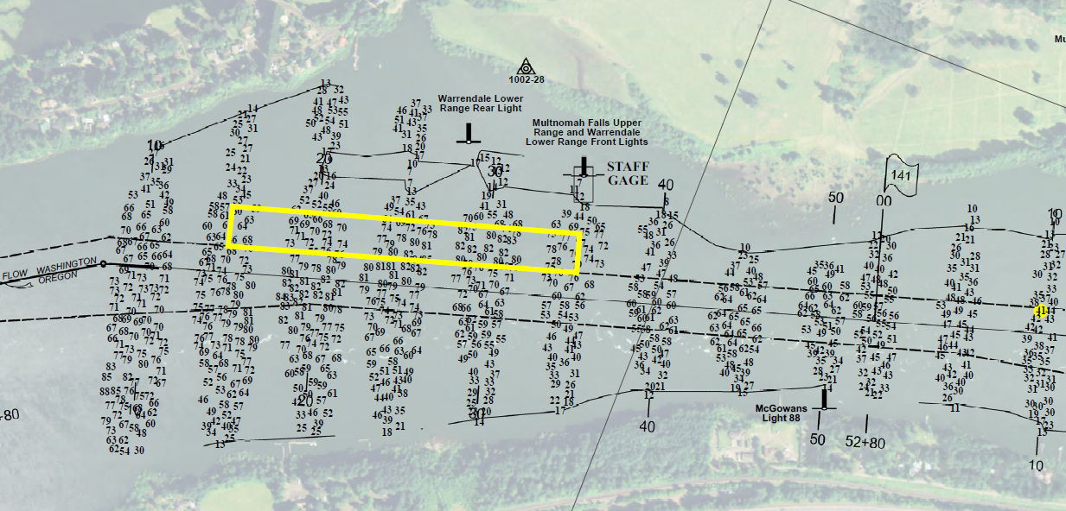
Figure 1-2 BON Dam NL1 Maint Dredge Project revised proposed placement site at Columbia Flowlane at RM 141 (avoids sediment loading of Chum spawning areas in the Ives-Perce complex).

Type of outage required- None

Impact on facility operation- None, no impacts to Bonneville Dam or Fish Passage Operations, NL1 is currently not in use.

Dates of impacts/repairs- Work planned for Bonneville dam In Water Work Windows, Jan 14-31, 2024.

Length of time for repairs- 1-2 weeks total for mobilization, dredging of NL1 concrete sill/apron (~2500 CYs), and downriver transport and placement (Columbia River flow lane RM 141).

Analysis of potential impacts to fish-
This work is scheduled to occur during the normal winter maintenance period. There should be minimal impacts to ESA listed fish.

Summary statement –
Expected impacts on any fish species are minimal (from dredging action at Bonneville NL1 as well as in water deposition of sediment in Columbia River Flowlane at RM 141), due to work being conducted within Bonneville Dam in water work window (Nov-Feb) and historically documented reduced fish passage on Columbia River at Bonneville during that time. In addition, current BON Ops plan for IWW 2023/2024 is for a complete shutdown of fish passages for scheduled maintenance during the 2023/2024 IWW window, further reducing any expected impacts to listed species. However, some species impacts are expected during actual dredge operations as Larval/Juvenile Lamprey, expected to inhabit the BON NL1 concrete apron sediment acumulation, and their habitat will be destroyed (and subsequenty relocated), while sediments are removed via dredge suction device or mechanical clamshell dredge. Dredging contractor has been provided with Best Mgmt Practices (BMPs, see Ref:(1)) designed specifically to minimize impacts to lampreys during dredging actions, such as (list not all inclusive):

- Lamprey Technical Workgroup (LTWG, 2020) recommends placing dredged sediments in fast currents to dissipate sediments and allow lamprey to drift downstream.
- If spoils are to be placed in-water, conduct a pre-disposal assessment of the disposal site. If larval lamprey are present, the disposal site should be reconsidered (e.g., an alternative in-water site).
- Dispose of dredge spoils in the watered areas away from redds, areas known to have high concentrations of predatory fishes, and areas known to have high densities of larval lampreys (i.e., river mouths; Harris and Jolley 2017).
- Do not allow dredged materials containing Larval/Juvenile Lamprey to dry out on barge, frequently apply water to sediment, and return sediment to water (placement site) as soon as possible.
The proposed action (maintenance dredging at BON NL1 upstream concrete apron) is in line with O&M activities as found “not likely to jeopardize” protected anadromous fish spp. and “will not destroy or adversely modify designated critical habitat for the same species” per 2020 NMFS Biological Opinion for Continued Operation and Maintenance of the Columbia River System, Sections 1.3.1.5 (Operations for Navigation) and 1.3.1.7 (System Maintenance). In addition, a minimal Environmental Remediation benefit is expected to be realized from retention of the sediment material in the Columbia River flowlane as the natural channel flow transports the sediment as nourishing materials for downstream wetland replenishment in place of deposits that naturally erode away due to wave action, wind, etc.

Expected impacts
Downstream migrants: Juvenile salmonid minor impacts only expected due to historic salmonid run periods are outside proposed work window (BON IWW Dec-Feb).

Upstream migrants (including Bull Trout): Adult passage, including bull trout, minor impacts only expected due to historic salmonid run periods are outside proposed work window (BON IWW Dec-Feb).

Lamprey: Juvenile/larval lamprey currently existing in the nav lock concrete apron sediment accumulation may be disturbed/collected/injured/killed via the limited dredging action (either through direct dredging impacts, being crushed under sediment in the barge, or by predation after return to the river). Dredging contractor to be provided Best Mgmt Practices (BMPs) designed specifically to minimize impacts to lampreys during dredging actions (ref: Ref: (1)).

Ref: (1) Pacific Lamprey Cons; Monitoring and Minimizing Effects of Dredging on Lampreys, Living Document, Original Version 1.0, March 2021, Lamprey Technical Workgroup

Comments from agencies:
USACE/NOAA –
-----Original Message-----
From: Trevor Conder - NOAA Federal <trevor.conder@noaa.gov>
Sent: Tuesday, June 27, 2023 10:17 AM
To: Mackey, Tammy M CIV USARMY CENWP (USA) <Tammy.M.Mackey@usace.army.mil>; Mcclain, Nathan A CIV USARMY CENWP (USA) <Nathan.A.McClain@usace.army.mil>; Derugin, Andrew G CIV (USA) <Andrew.G.Derugin@usace.army.mil>; Kelsey Swieca - NOAA Federal <kelsey.swieca@noaa.gov>
Subject: [URL Verdict: Neutral][Non-DoD Source] Re: FPOM: Official Coordination - updated 23BON024 MOC Old Navlock dredge placement

Tammy,

The MOC does not describe how the dredge material will be dispersed at RKM 144 (Near Hamilton Island) so that it will not negatively impact incubating chum fry in that area. Do you have any more information that indicates there will not be any existing redds near the deposition site, and any fry in redds near or downstream of the deposition site will not be impacted by sediment deposition? Please update the MOC to include this information. Thanks

-Trevor

--

Trevor Conder
NOAA Fisheries
260 Mystery Drive
Amboy Wa 98601
(360) 247-6733
(360) 953-3875 Cell

-----Original Message-----
From: Derugin, Andrew G CIV (USA) <Andrew.G.Derugin@usace.army.mil>
Sent: Thursday, June 29, 2023 9:33 AM
Subject: RE: Revised FPOM MOC Bon NL1 Dredging

Hi Barry,

Do you have a map that shows the specific dredge placement location at RM 144?

V/r,

Andrew Derugin
Supervisory Fish Biologist
Bonneville Lock & Dam
U.S. Army Corps of Engineers
Office: 541-374-3879
Cell: 503-278-2376

-----Original Message-----
From: Moncrief, James B (Barry) CIV USARMY CENWP (USA) <James.B.Moncrief@usace.army.mil>
Sent: Thursday, June 29, 2023 11:10 AM
Subject: RE: Revised FPOM MOC Bon NL1 Dredging

I do not have specific dredge placement location.

My understanding with the PDT is they were remaining flexible with exact depo location as to be in line with any forthcoming guidance.

CR Flowlane @RM 144 was all I was going with for my in-process ODEQ water quality cert application as well.

I reached out to USACE dredge contract mgr. yesterday with info on potential fish spawning habitat near RM144, as a heads up for possible relocation.

Nathan sent me link to WDFW PHS mapper and I ran the attached with the proposed depo site and 100m radius if this helps.

Looking forward to resolving soon, thanks!

Barry

-----Original Message-----
From: Derugin, Andrew G CIV (USA) <Andrew.G.Derugin@usace.army.mil>
Sent: Thursday, June 29, 2023 11:53 AM
Subject: RE: Revised FPOM MOC Bon NL1 Dredging

Barry,

Slide 1 of the attached set shows three Chum spawning areas downstream, with 2 of them being in very close proximity. Could we set up a conversation with the appropriate entities to discuss the possibility of moving the release site ~2.5 miles downstream? I'm not the expert or the authority on this site but I can help prepare a reasonable alternative.

Supporting info:
- The attached graph shows that during the working period, the areas surveyed (at 10.5' Bon tailwater) are usually under several feet of water in January.
-The attached teletype is standard annual practice and controls the water level there specifically for these fish.

V/r,

Andrew Derugin
Supervisory Fish Biologist
Bonneville Lock & Dam
U.S. Army Corps of Engineers
Office: 541-374-3879
Cell: 503-278-2376

USFWS – comments in the document in track changes. Responses also in the document.

Yakama Nation - From: Ralph Lampman <lamr@yakamafish-nsn.gov <mailto:lamr@yakamafish-nsn.gov> >
Sent: Saturday, June 3, 2023 6:26 AM
To: Mackey, Tammy M CIV USARMY CENWP (USA) <Tammy.M.Mackey@usace.army.mil <mailto:Tammy.M.Mackey@usace.army.mil> >
Subject: [URL Verdict: Neutral][Non-DoD Source] Re: FPOM: Official Coordination - 23BON24 MOC Old navlock dredge placement
Hi Tammy,
What specifically are the "management practices" that are mentioned below?

Lamprey: Juvenile/larval lamprey may be disturbed/collected/injured via limited
dredging action. Contractor to be advised to mitigate impacts via management practices

I have heard quite a few (hundreds of juvenile lamprey) have been found here in the past and would be important to make a concerted effort to both rescue them as well as document them (subsample some for life stage [larva vs. juveniles], genetics, etc. to find out where the source of these lamprey(s) are).

~Warm Regards~
Ralph Lampman
COLUMBIA RIVER| Honor. Protect. Restore
Yakama Nation FRMP, Pacific Lamprey Project
lamr@yakamafish-nsn.gov <mailto:lamr@yakamafish-nsn.gov>
509-388-3871

-----Original Message-----
From: Ralph Lampman <lamr@yakamafish-nsn.gov>
Sent: Monday, June 12, 2023 5:06 PM
To: Moncrief, James B (Barry) CIV USARMY CENWP (USA) <James.B.Moncrief@usace.army.mil>
Subject: [URL Verdict: Neutral][Non-DoD Source] Re: FPOM: Official Coordination - 23BON24 MOC Old NavLock dredge and placement
👍👍
Awesome

~Warm Regards~

Ralph T. Lampman
Lamprey Research Biologist
Yakama Nation FRMP
Pacific Lamprey Project

On Mon, Jun 12, 2023, 2:10 PM Moncrief, James B (Barry) CIV USARMY CENWP (USA) <James.B.Moncrief@usace.army.mil <mailto:James.B.Moncrief@usace.army.mil> > wrote:

Ralph,
Thank you for the excellent guidance documents on lamprey protection during dredging and in water operations.
I’ll forward this info to our dredge team for their guidance as well as my own. Very helpful!
Barry
James B. Moncrief (Barry)
U.S. Army Corps of Engineers, Portland District
Environmental Resource Specialist
Environmental Resources Branch
Phone: 503-808-5101
Email: james.b.moncrief@usace.army.mil <mailto:james.b.moncrief@usace.army.mil>

From: Ralph Lampman <lamr@yakamafish-nsn.gov <mailto:lamr@yakamafish-nsn.gov> >
Sent: Friday, June 9, 2023 8:04 AM
To: Moncrief, James B (Barry) CIV USARMY CENWP (USA) <James.B.Moncrief@usace.army.mil <mailto:James.B.Moncrief@usace.army.mil> >
Subject: [URL Verdict: Neutral][Non-DoD Source] Re: FPOM: Official Coordination - 23BON24 MOC Old NavLock dredge and placement
Hi Barry,
The link below is the latest guideline from PL Conservation Initiative Lamprey Technical Work Group on this topic (dredging):

Monitoring and Minimizing Effects of Dredging on Lampreys
https://www.pacificlamprey.org/wp-content/uploads/2022/02/Dredging_-and_Lampreys_03.19.21.pdf

The link below provides more specifics on how to handle lamprey once you encounter them:
Best Management Guidelines for Native Lampreys During In-water Work
https://www.pacificlamprey.org/wp-content/uploads/2022/10/BMGs-for-Native-Lampres-During-In-Water-Work-Final-Updated-2022-2.pdf

If there are any questions, happy to help.
Appreciate your help on this.
~Warm Regards~
Ralph Lampman
COLUMBIA RIVER| Honor. Protect. Restore
Yakama Nation FRMP, Pacific Lamprey Project
lamr@yakamafish-nsn.gov <mailto:lamr@yakamafish-nsn.gov>
509-388-3871

USACE/BPA –
From: Mcclain, Nathan A CIV USARMY CENWP (USA) <Nathan.A.McClain@usace.army.mil <mailto:Nathan.A.McClain@usace.army.mil> >
Sent: Thursday, June 8, 2023 12:17 PM
To: Ralph Lampman <lamr@yakamafish-nsn.gov <mailto:lamr@yakamafish-nsn.gov> >; Mackey, Tammy M CIV USARMY CENWP (USA) <Tammy.M.Mackey@usace.army.mil <mailto:Tammy.M.Mackey@usace.army.mil> >
Subject: [EXTERNAL] RE: [URL Verdict: Neutral][Non-DoD Source] Re: FPOM: Official Coordination - 23BON24 MOC Old navlock dredge placement

Ralph,

To clarify the dredging will take place in front of the old nav lock. They need to clean up sediment that has settled into the bulkhead slot, upstream of the gate, so the bulkhead can be put in place.

I’ve been told it has [HASN’T been used or dredged since the 1990’s. No lamprey work has been done in that area. The only area dredged at Bonn that has been surveyed for lamprey is the Bradford Island adult ladder exit. Ben] been used (or dredge) since the 1990’s. So I do not know of any work that indicates 100’s of juveniles there but wouldn’t be surprised if there are some. If you have different information please let me know.

More importantly I will try to find out what management practices will be implemented to protect lamprey.

Nathan

From: Macdonald, Jacob B CIV USARMY CENWP (USA) <Jacob.Macdonald@usace.army.mil <mailto:Jacob.Macdonald@usace.army.mil> >
Sent: Thursday, June 8, 2023 3:34 PM
To: Hausmann,Benjamin J (BPA) - EWP-4 <bjhausmann@bpa.gov <mailto:bjhausmann@bpa.gov> >; Mcclain, Nathan A CIV USARMY CENWP (USA) <Nathan.A.McClain@usace.army.mil <mailto:Nathan.A.McClain@usace.army.mil> >; Ralph Lampman <lamr@yakamafish-nsn.gov <mailto:lamr@yakamafish-nsn.gov> >; Mackey, Tammy M CIV USARMY CENWP (USA) <Tammy.M.Mackey@usace.army.mil <mailto:Tammy.M.Mackey@usace.army.mil> >
Subject: RE: [EXTERNAL] RE: [URL Verdict: Neutral][Non-DoD Source] Re: FPOM: Official Coordination - 23BON24 MOC Old navlock dredge placement

I think Ralph may be remembering reports of substantial numbers of juvenile lamprey we’ve observed in the chamber of the new nav lock during annual dewatering. If we see them inside the active nav lock, it’s a pretty safe bet there’s juvenile lamprey in the sediment in and around the old nav lock too.

How are we doing this dredging? With a suction hose or a clamshell? Is there an opportunity anywhere in the handling process for an interested researcher to sift through the dredge material looking for lamprey?

From: Mcclain, Nathan A CIV USARMY CENWP (USA) <Nathan.A.McClain@usace.army.mil <mailto:Nathan.A.McClain@usace.army.mil> >
Sent: Thursday, June 8, 2023 3:38 PM
To: Macdonald, Jacob B CIV USARMY CENWP (USA) <Jacob.Macdonald@usace.army.mil <mailto:Jacob.Macdonald@usace.army.mil> >; Hausmann,Benjamin J (BPA) - EWP-4 <bjhausmann@bpa.gov <mailto:bjhausmann@bpa.gov> >; Ralph Lampman <lamr@yakamafish-nsn.gov <mailto:lamr@yakamafish-nsn.gov> >; Mackey, Tammy M CIV USARMY CENWP (USA) <Tammy.M.Mackey@usace.army.mil <mailto:Tammy.M.Mackey@usace.army.mil> >
Cc: Moncrief, James B (Barry) CIV USARMY CENWP (USA) <James.B.Moncrief@usace.army.mil <mailto:James.B.Moncrief@usace.army.mil> >
Subject: RE: [EXTERNAL] RE: [URL Verdict: Neutral][Non-DoD Source] Re: FPOM: Official Coordination - 23BON24 MOC Old navlock dredge placement

Barry, do you have any insight on the proposed dredging method? Also see Jake question below [above]:

From: Moncrief, James B (Barry) CIV USARMY CENWP (USA) <James.B.Moncrief@usace.army.mil <mailto:James.B.Moncrief@usace.army.mil> >
Sent: Thursday, June 8, 2023 4:18 PM
To: Mcclain, Nathan A CIV USARMY CENWP (USA) <Nathan.A.McClain@usace.army.mil <mailto:Nathan.A.McClain@usace.army.mil> >; Macdonald, Jacob B CIV USARMY CENWP (USA) <Jacob.Macdonald@usace.army.mil <mailto:Jacob.Macdonald@usace.army.mil> >; Hausmann,Benjamin J (BPA) - EWP-4 <bjhausmann@bpa.gov <mailto:bjhausmann@bpa.gov> >; Ralph Lampman <lamr@yakamafish-nsn.gov <mailto:lamr@yakamafish-nsn.gov> >; Mackey, Tammy M CIV USARMY CENWP (USA) <Tammy.M.Mackey@usace.army.mil <mailto:Tammy.M.Mackey@usace.army.mil> >; Griffith, David W CIV USARMY CENWP (USA) <David.W.Griffith@usace.army.mil <mailto:David.W.Griffith@usace.army.mil> >
Subject: Re: FPOM: Official Coordination - 23BON24 MOC Old NavLock dredge and placement

From Dredging Contracts Team Lead (Terry Geroux):
“I would anticipate that we’d see a combo of mechanical and hydraulic, with the bulk of the material being dredged mechanically”

We figure at least some suction dredging to clear out Nav Lock stoplogs channels so new stoplogs will fit…

Dredging team is also looking for: “Can your ESA person offer up any sort of restrictions or BMPs that would have to be followed to minimize lamprey injury? It’s not something that we encounter typically.”

So to me this looks like they would (possibly) be receptive to ride along fish guy, but would have to ask. I think this would be very beneficial from overall species protection standpoint as well.

And if you have any specific lamprey precautions for the team, pls pass them along, cheers.

Barry

James B. Moncrief (Barry)
U.S. Army Corps of Engineers, Portland District
Environmental Resource Specialist
Environmental Resources Branch
Phone: 503-808-5101
Email: james.b.moncrief@usace.army.mil <mailto:james.b.moncrief@usace.army.mil>

WDFW

Hi Tammy,

We appreciate the opportunity to provide comments expressing our concerns on 3BON024 MOC Old Navlock dredge placement.

WDFW opposes disposal of dredge materials at RM 144 to avoid the possibility of any added silt to spawning areas in the Ives-Perce complex that could degrade currently available and utilized spawning sites for the listed Chum salmon population. The lower site poses less risk but does not totally alleviate risks to areas of suitable spawning habitat below RM 141.

There is also some probability of impacts to winter steelhead moving upriver during the dredging work and placement of the dredged materials and there is PIT data that shows some kelt fallback through the Bonneville Corner Collector in January.

Thank you!

Charlie

Final coordination results:

Please email or call with questions or concerns.
Thank you,

Tammy Mackey
Columbia River Coordinator
503-808-4318
Tammy.m.mackey@usace.army.mil

J Barry Moncrief, Portland District Env Resource Specialist
Env Resources Branch
Phone: 503-808-5101
Email: james.b.moncrief@usace.army.mil

David Griffith
Endangered Species Act Coordinator
USACE Portland District
(503) 808-4773
Email: David.W.Griffith@usace.army.mil

